Polymers - In-Class Activity

Group # ___ Group Names:

Pre-Class Assignments:
Societal Concept: Social and cultural systems such as language, gender, aesthetics, home design, and advertising shapes the ways we perceive the intrinsic physical properties of materials.

ASSIGNMENT: Groups will act as Ad Agencies to propose a campaign for pitching bio polymer bicycle helmets to a target demographic. The group proposals must highlight polymer’s properties and selling points. Students will draw from the successful Tupperware Brands campaign and classic American advertising strategies to create their contemporary approach to selling bicycle helmets. Each group will focus on 1 target demographic:
Groups 1-7: Decision makers for a bicycle safety program in elementary schools
Groups 8-14: Athletes—can be male, female, or both; think of an ad that would appear in Cycle World, Road Bike Action, Triathlete, Runner’s World, or another sports & fitness magazine
Groups 15-21: Mothers between the ages of 25-35
Groups 22-28: Buyers for big-box sporting goods stores such as Sports Authority or Dick’s Sporting Goods
Groups 29-35: BMX teen boys

About Paragraphs: Think of your individual paragraphs as micro-essays that answer the question with specific examples. Your first sentence will be a claim that your paragraph will develop or prove. (Some call these opening claims topic sentences.) Good claims help you focus and organize paragraphs. The rest of each paragraph will be 5-6 sentences that offer the most relevant details and examples to support your claim.

Bullet Point List 1: What properties of polymers make them potentially attractive to consumers? (5-7 sentences)
Bullet Point List 2 (cont):

Bullet Point List 2: How would your group pitch a polymer-based bicycle helmet to your target demographic? Thumbnail 3 specific selling points for your ad campaign, from most to least important.
Paragraph: How would your group pitch a bio polymer-based bicycle helmet to your target demographic? Describe your ad agency’s approach to the campaign in a 4-5 sentence paragraph. Include 1 classic American advertising strategy you learned from Bryant’s chapter.
Brand Name/Slogan: Give your Brand Name for your helmet, and a slogan to use in the ad campaign (just a phrase or single sentence for the slogan).

Your grade will be determined from the following criteria.
Grading Rubric.
5= Responses are appropriate and indicate engagement with the preparatory material. Grammar, sentence structure and punctuation are correct.
4= Responses and arguments are not as clearly presented. Some minor issues with grammar, punctuation and or sentence structure.
3= Responses are not appropriate to the assignment and do not reinforce the physical and cultural properties of materials. Mistakes in grammar, punctuation and or sentence structure.
2= Responses are incomplete. Major problems with grammar, punctuation and or sentence structure.
1= Responses are inconsistent with material covered in class, videos, and readings. Missing elements of assignment. Poor grammar, punctuation and or sentence structure.

CHOOSE ONE OF THESE ADS for Bullet Point List 1:
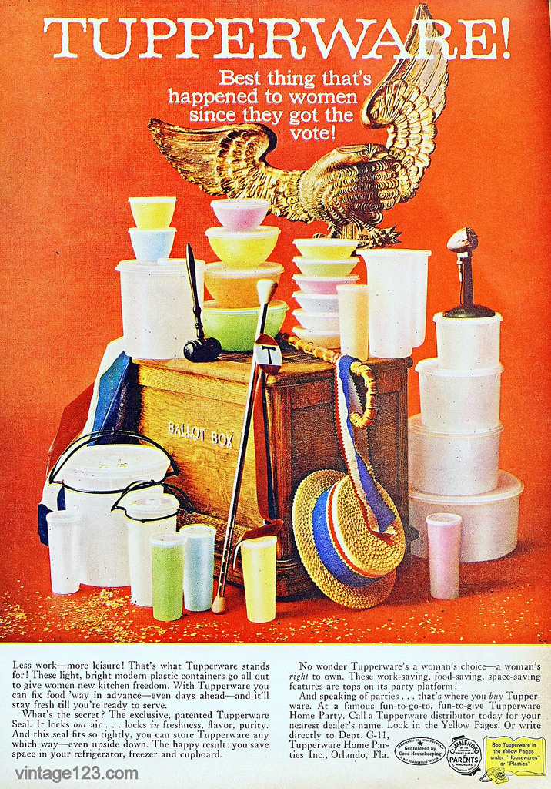
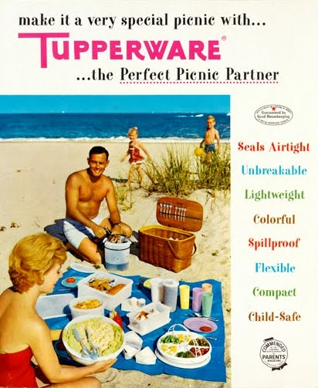

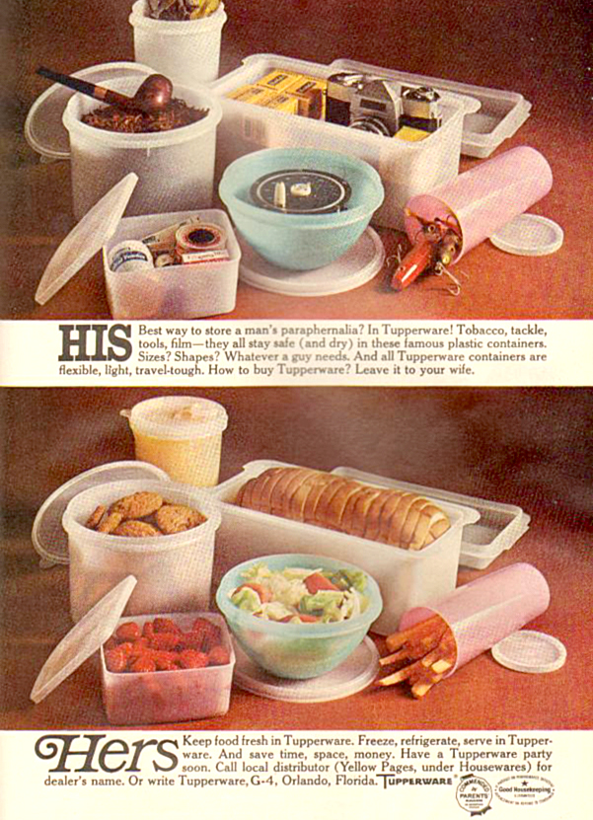
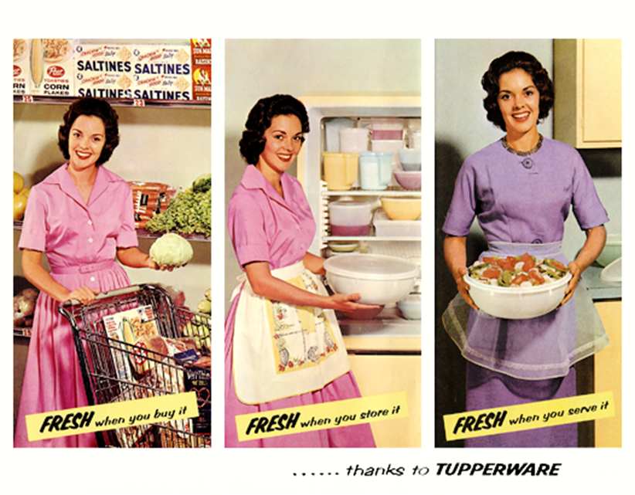
*All classic ads for Tupperware products from Google Image search

