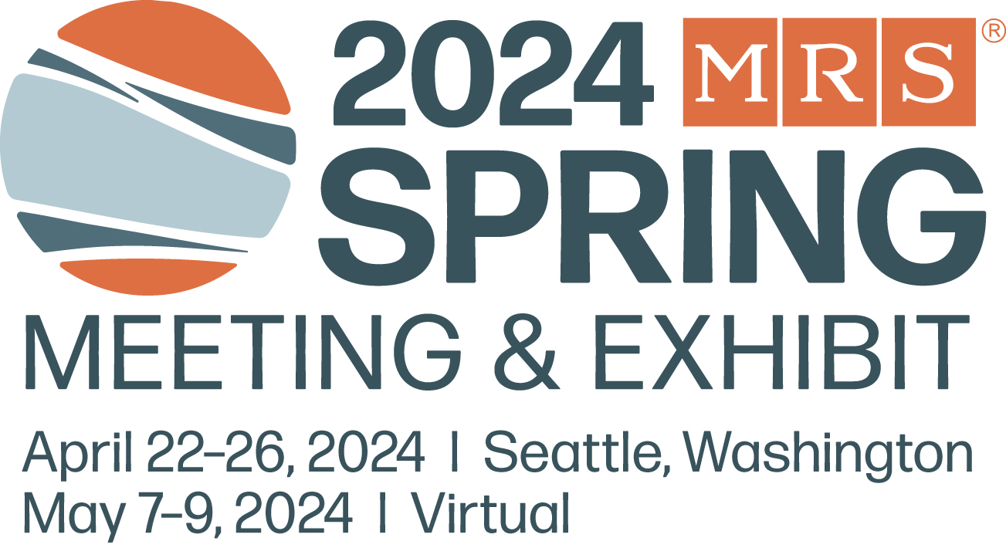
MRS Childcare Grant Application
2024 MRS Spring Meeting
Submit Completed Application
by April 5, 2024 to cc@mrs.org

Full Name: First Name Last Name
Email Address:
Company/Institution: Title:
Address:
(Please provide full address for mailing a bank check (pending grant approval and receiving expense receipts)
Address:
City, State, Zip/Postal Code:
Country:
I. Career Status: (Please select one)
Undergraduate Student Graduate Student PhD Student Postdoctoral Fellow
Early-career, independent scientist (state degree and year obtained):
Junior faculty member (state degree and year obtained):
Senior faculty member or later-career scientist (state degree and year obtained):
Other, please specify:

II. Funds may be applied to one or more of the following needs. Please check all that apply:
A. Home-based childcare expenses incurred because of Spring Meeting attendance.
(funds may not be applied to a normal ongoing expense.)
B. Travel of a relative or other care provider to my home to care for my child(ren) while I attend the
MRS Meeting.
Please indicate where the provider is traveling to/from: ___________________________________________
C. Travel of my child(ren) to the location of a care provider who does not live in my community.
Please indicate where the child(ren) will be cared for (city/state/country if not U.S.):
D. Travel of a care provider to the MRS Meeting with me to care for my child(ren) in city of MRS Meeting.
Please indicate where the provider will be traveling from:
E. Child care to be retained in city of meeting during meeting week
F. Other (please explain):
III. I am presenting at the 2024 MRS Spring Meeting: Yes or No
IV: I have ___ child(ren) and they are age(s):______________________________________________________________
---------------------------------------------------------------------------------------------------------------------------------------------------------------------------
Meeting Preregistration at time of childcare application submission is REQUIRED:
I (insert name/please print) ____________________________ confirm that I am pre-registered for the
2024 MRS Spring Meeting as of the date that I submitted this application.
Date: _________________________________

